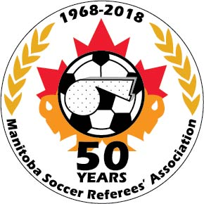MANITOBA SOCCER REFEREES’ ASSOCIATION

October 9, 2020

Good day MSRA members:

The MSRA Annual General Meeting is quickly approaching and same will need to be held virtually by ZOOM on Thursday, November 19, 2020 7:30pm. A link for same will be sent out in November closer to the meeting date.
The attached package has the following documents:
- AGM Agenda
- Proposed AGM Minutes from the 2019 AGM
- Proposed Bylaw Amendment form (provided to the membership at least 30 days before the proposed meeting)
- Nominee Profiles and Nomination forms for Board postions open for re-election
- Blank Nomination form and Nominee Profile
- Financial Statements of the MSRA
- Current bylaws of the MSRA with markups of revisions
- Proposed bylaws without markups
The Proposed Bylaw Amendment seeks to repeal the entire bylaws of the MSRA and replace them with a revised version. The Governance Committee has worked very hard on this revision with Andrew Brown as the Governance Chair and Nic Joubert and Aubrey Kotelko as committee members. It is being proposed that the bylaws of the MSRA be repealed and replaced with the version attached to this email. Note that a vote of two-thirds of the members at the AGM will be required for this motion to pass. NO AMENDMENTS WILL BE ENTERTAINED AT THE AGM. Therefore, should you have any comments or suggested amendments, these are to be brought to the attention of the Board (via the Secretary) no later than November 10, 2020 using the attached by-law amendment form. Although we normally have to have these in 30 days before the AGM, we are extending the time to respond to the proposed amendments, as it is not an actual amendment to the bylaws but discussion on the proposed amendment. If you want to do a formal BYLAW AMENDMENT, you will need to have the amendment before us by October 19, 2020.
The following positions that are open on the MSRA Board are as follows:
President – Lisa Sansregret
Treasurer – Cody Baldauf
Director A – Frank Major, Director C – Dave Holder, Director E – Bryan Mintenko
If you are interested in a board position, please have a fellow member put your name forward and fill out a Nominee Profile and forward same to manitobasoccerreferees@gmail.com
If no further nominees come forward the above nominees will be declared elected by acclamation at the AGM.
Thank you for your attention to this.

MSRA BOARD

